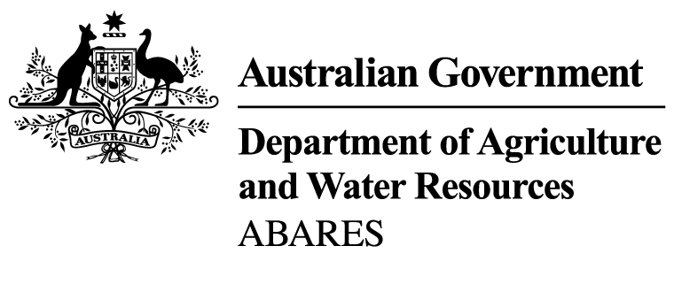

Report title

Supplementary report title

Author name

**Research by the Australian Bureau of Agricultural  
and Resource Economics and Sciences**

Publication series

May 2016

INSERT ABARES Biosphere

Available from the ABARES team site

[http://mylink.agdaff.gov.au/team/abares/PublishingImages/Forms/AllItems.aspx?RootFolder=/team/abares/PublishingImages/New%20ABARES%20Biospheres&FolderCTID=&View={EB907063-4A2F-47EA-9720-EBD3B0525CB7}](http://mylink.agdaff.gov.au/team/abares/PublishingImages/Forms/AllItems.aspx?RootFolder=/team/abares/PublishingImages/New%20ABARES%20Biospheres&FolderCTID=&View=%7bEB907063-4A2F-47EA-9720-EBD3B0525CB7%7d)

© Commonwealth of Australia 2016

Ownership of intellectual property rights

Unless otherwise noted, copyright (and any other intellectual property rights, if any) in this publication is owned by the Commonwealth of Australia (referred to as the Commonwealth).

Creative Commons licence

All material in this publication is licensed under a Creative Commons Attribution 3.0 Australia Licence, save for content supplied by third parties, logos and the Commonwealth Coat of Arms.

by

Creative Commons Attribution 3.0 Australia Licence is a standard form licence agreement that allows you to copy, distribute, transmit and adapt this publication provided you attribute the work. A summary of the licence terms is available from [creativecommons.org/licenses/by/3.0/au/deed.en](http://creativecommons.org/licenses/by/3.0/au/deed.en). The full licence terms are available from [creativecommons.org/licenses/by/3.0/au/legalcode](http://creativecommons.org/licenses/by/3.0/au/legalcode).

Cataloguing data

Author, A, Author, B & Author, C 2016, [Report title] ABARES [research report, technical report, report to client prepared for the ‘insert name of client’], Canberra, [Month]. CC BY 3.0.

ISSN XXXXXXX

ISBN XXXXXXX

ABARES project 4XXXX

Internet

[Report title] is available at [agriculture.gov.au/abares/publications](http://agriculture.gov.au/abares/publications).

Australian Bureau of Agricultural and Resource Economics and Sciences (ABARES)

Postal address GPO Box 858 Canberra ACT 2601

Switchboard +61 2 6272 3933

Email [info.abares@agriculture.gov.au](mailto:info.abares@agriculture.gov.au)

Web [agriculture.gov.au/abares](http://agriculture.gov.au/abares/)

Inquiries about the licence and any use of this document should be sent to [copyright@agriculture.gov.au](mailto:copyright@agriculture.gov.au).

The Australian Government acting through the Department of Agriculture and Water Resources, represented by the Australian Bureau of Agricultural and Resource Economics and Sciences, has exercised due care and skill in preparing and compiling the information and data in this publication. Notwithstanding, the Department of Agriculture and Water Resources, ABARES, its employees and advisers disclaim all liability, including for negligence and for any loss, damage, injury, expense or cost incurred by any person as a result of accessing, using or relying on information or data in this publication to the maximum extent permitted by law.

Acknowledgements

The authors thank interview and survey participants for their input. Thanks also to Caroline Leung and Stefano Missoni for their support during the project and in preparing this report.

Foreword

This paper is one of two background papers prepared as part of a collaborative project between ABARES and the Forestry Economics and Development Research Center (FEDRC) of China’s State Forestry Administration to develop a sustainable land and forest management research agenda. The other paper is Sustainable forest management: the Australian context (Clancy & Howell 2012).

The Sustainable Land and Forest Management Research Agenda project, funded through AusAID’s Australia China Environment Development Partnership (ACEDP) programme, has strengthened technical cooperation in areas of common interest in sustainable forest management and land resources assessment.

The two background papers supported discussions held by FEDRC and ABARES (in Beijing in October 2011 and in Canberra in December 2011). The discussions led to agreement on common areas of research interest in sustainable forest management and land resources assessment. The project partners ABARES and FEDRC intend to use the papers as background information to support collaborative engagement and as reports to the ACEDP managing contractor (GHD Pty Ltd) and AusAID.

Contents

Foreword iii

Summary vi

1 Introduction 6

2 Chapter heading 6

Heading style 2 6

Appendix A: Production estimates 6

Glossary 6

References 6

Tables

Table 1 Total plantation area, by jurisdiction, 2011‑12 6

Table 2 Assumptions used in business-as-usual scenario 6

Table A1 New plantation areas, 2000, 2005, 2011 and 2012 6

Table A2 Notes on southern bluefin tuna recreational fishing activities and monitoring programmes based on presentations and discussions at the 2011 technical workshop 6

Figures

Figure 1 Hemp seed processing and products 6

Figure 2 Index of price received, by vegetable crop, 2005‑06 to 2011‑12 6

Maps

Map 1 National Plantation Inventory regions 6

Boxes

Box 1 Case study: Importance of flexibility in programmes 6

Summary

Native vegetation management on Australia’s agricultural land is important for landscape condition, biodiversity and soil health and for providing native pastures. It can also contribute to climate change mitigation and adaptation. Understanding the links between native vegetation and management of agricultural land is critical to maintaining delivery of a mix of goods and services, particularly those related to environmental values.

Historically, the Australian community has benefitted from the increased extent and improved efficiency of agricultural production on farmland that was made possible by clearing native vegetation. As the extent of native vegetation has fallen its role in providing a range of environmental benefits has been increasingly recognised and during the latter part of the twentieth century society began to question whether broadscale clearing should continue.

All Australian governments have taken steps to limit further decline in the extent and condition of native vegetation; for example, state and territory based regulations restrict clearing of native vegetation. In addition, governments have invested in incentive and stewardship programmes, extension support and research and development to help and reward farmers who invest in native vegetation management, and enhance the public good benefits of native vegetation on agricultural land. A range of private sector initiatives has emerged and farmers are taking private action to enhance the extent and condition of native vegetation and the ecosystem services it provides.

This report focuses on the role of regulation and incentive programmes, together with extension services and private action, and their relevance to native vegetation management on agricultural land. It is supported by a national survey of 985 farmers designed specifically to address farmer attitudes to and involvement in native vegetation management. It also drew lessons from the literature and the experience of Australian and state and territory government agencies, natural resource management groups and landholders across Australia.

### Key findings

* The agricultural sector is playing an important role in managing native vegetation for environmental and production outcomes.
* Most farmers are managing native vegetation for both environmental and production outcomes and many intend to do more to improve the condition and extent of native vegetation.
* From a national perspective, intentions to clear formed a relatively small part of farmers’ intentions for native vegetation management, but there are regional differences.
* While most farmers who applied for government funding to manage native vegetation were successful, improvements could be made so farmers can more easily find out about and apply for funding programmes.
* Improving the transparency of purpose, operation and outcomes of government programmes and regulations would improve their effectiveness in delivering environmental outcomes through greater farmer engagement.
* Improving available market information and developing markets for environmental services may provide new opportunities to increase environmental outcomes and benefits to farmers.

There are opportunities to build on existing programmes to improve production and conservation outcomes on farmland. Farmers are uncertain about what the various levels of government want to achieve through the mix of regulation and incentive programmes. A challenge for natural resource managers, including farmers, is the changing nature of funding sources and objectives for programmes. This can act as a significant barrier to managing native vegetation on agricultural and other private land. Similarly, changing regulations create uncertainty for farmers and industry. As native vegetation management is a long-term process, a lack of continuity in policy can present a challenge for both farmers and for delivering long-term benefits. Greater stability in policy and particularly programme availability and funding is important. These features can be summarised as:

1. ecosystem characteristics
   1. plant and animal species
      1. threatened or endangered
      2. non-indigenous
   2. water availability
2. physical characteristics
   1. climatic variability
   2. densely forested.

Improved management of native vegetation will require a range of flexible approaches and greater recognition of the wider benefits of native vegetation. This report highlights the role of programmes, regulations, markets and extension in native vegetation management. Given the range of policy instruments available to government, it is necessary to understand how these instruments engage farmers and deliver outcomes. This can be used to improve the structure, operational requirements and flexibility of policy instruments. In doing so, it is important to ensure these instruments function at a scale relevant to protecting and improving native vegetation while delivering environmental and, potentially, production outcomes.

# Introduction

Hemp seed is produced commercially from a low tetrahydrocannabinol strain of the plant Cannabis sativa, which is commonly used for fibre production. Hemp seed oil can be used in a range of cosmetics and pharmaceutical products while hemp seed meal is mostly used as animal feed and protein powder (Figure 1).

Figure 1 Hemp seed processing and products

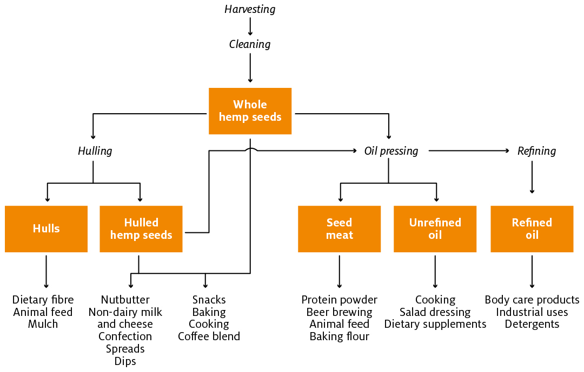

Source: North American Industrial Hemp Council

# Chapter heading

## Heading style 2

The Department of Fisheries’ price estimates are used to estimate gross value of production (GVP). These prices should represent a beach price that ABARES defines as:

The price paid to fishers at the wharf side for whole weight fish for landed catch on a per kilogram basis. As a wharf side price it does not include any cost mark ups for marketing and transport of catch to wholesale/retail markets or costs associated with on board processing of catch.

The [Atlas of Living Australia](http://www.ala.org.au/) website (ALA 2013) enables users to upload photographs and provide details of sightings of animals and plants.

### Heading style 3

Vegetable growing farms produce a variety of vegetable products and the prices farmers receive for these products can vary widely from year to year (ABARES 2012a). Indexes of vegetable prices show mixed results from 2005–06 to 2011–12. Overall, prices for potatoes, pumpkins and onions trended upward, while prices for carrots fell (Figure 2).

Figure 2 Index of price received, by vegetable crop, 2005–06 to 2011–12

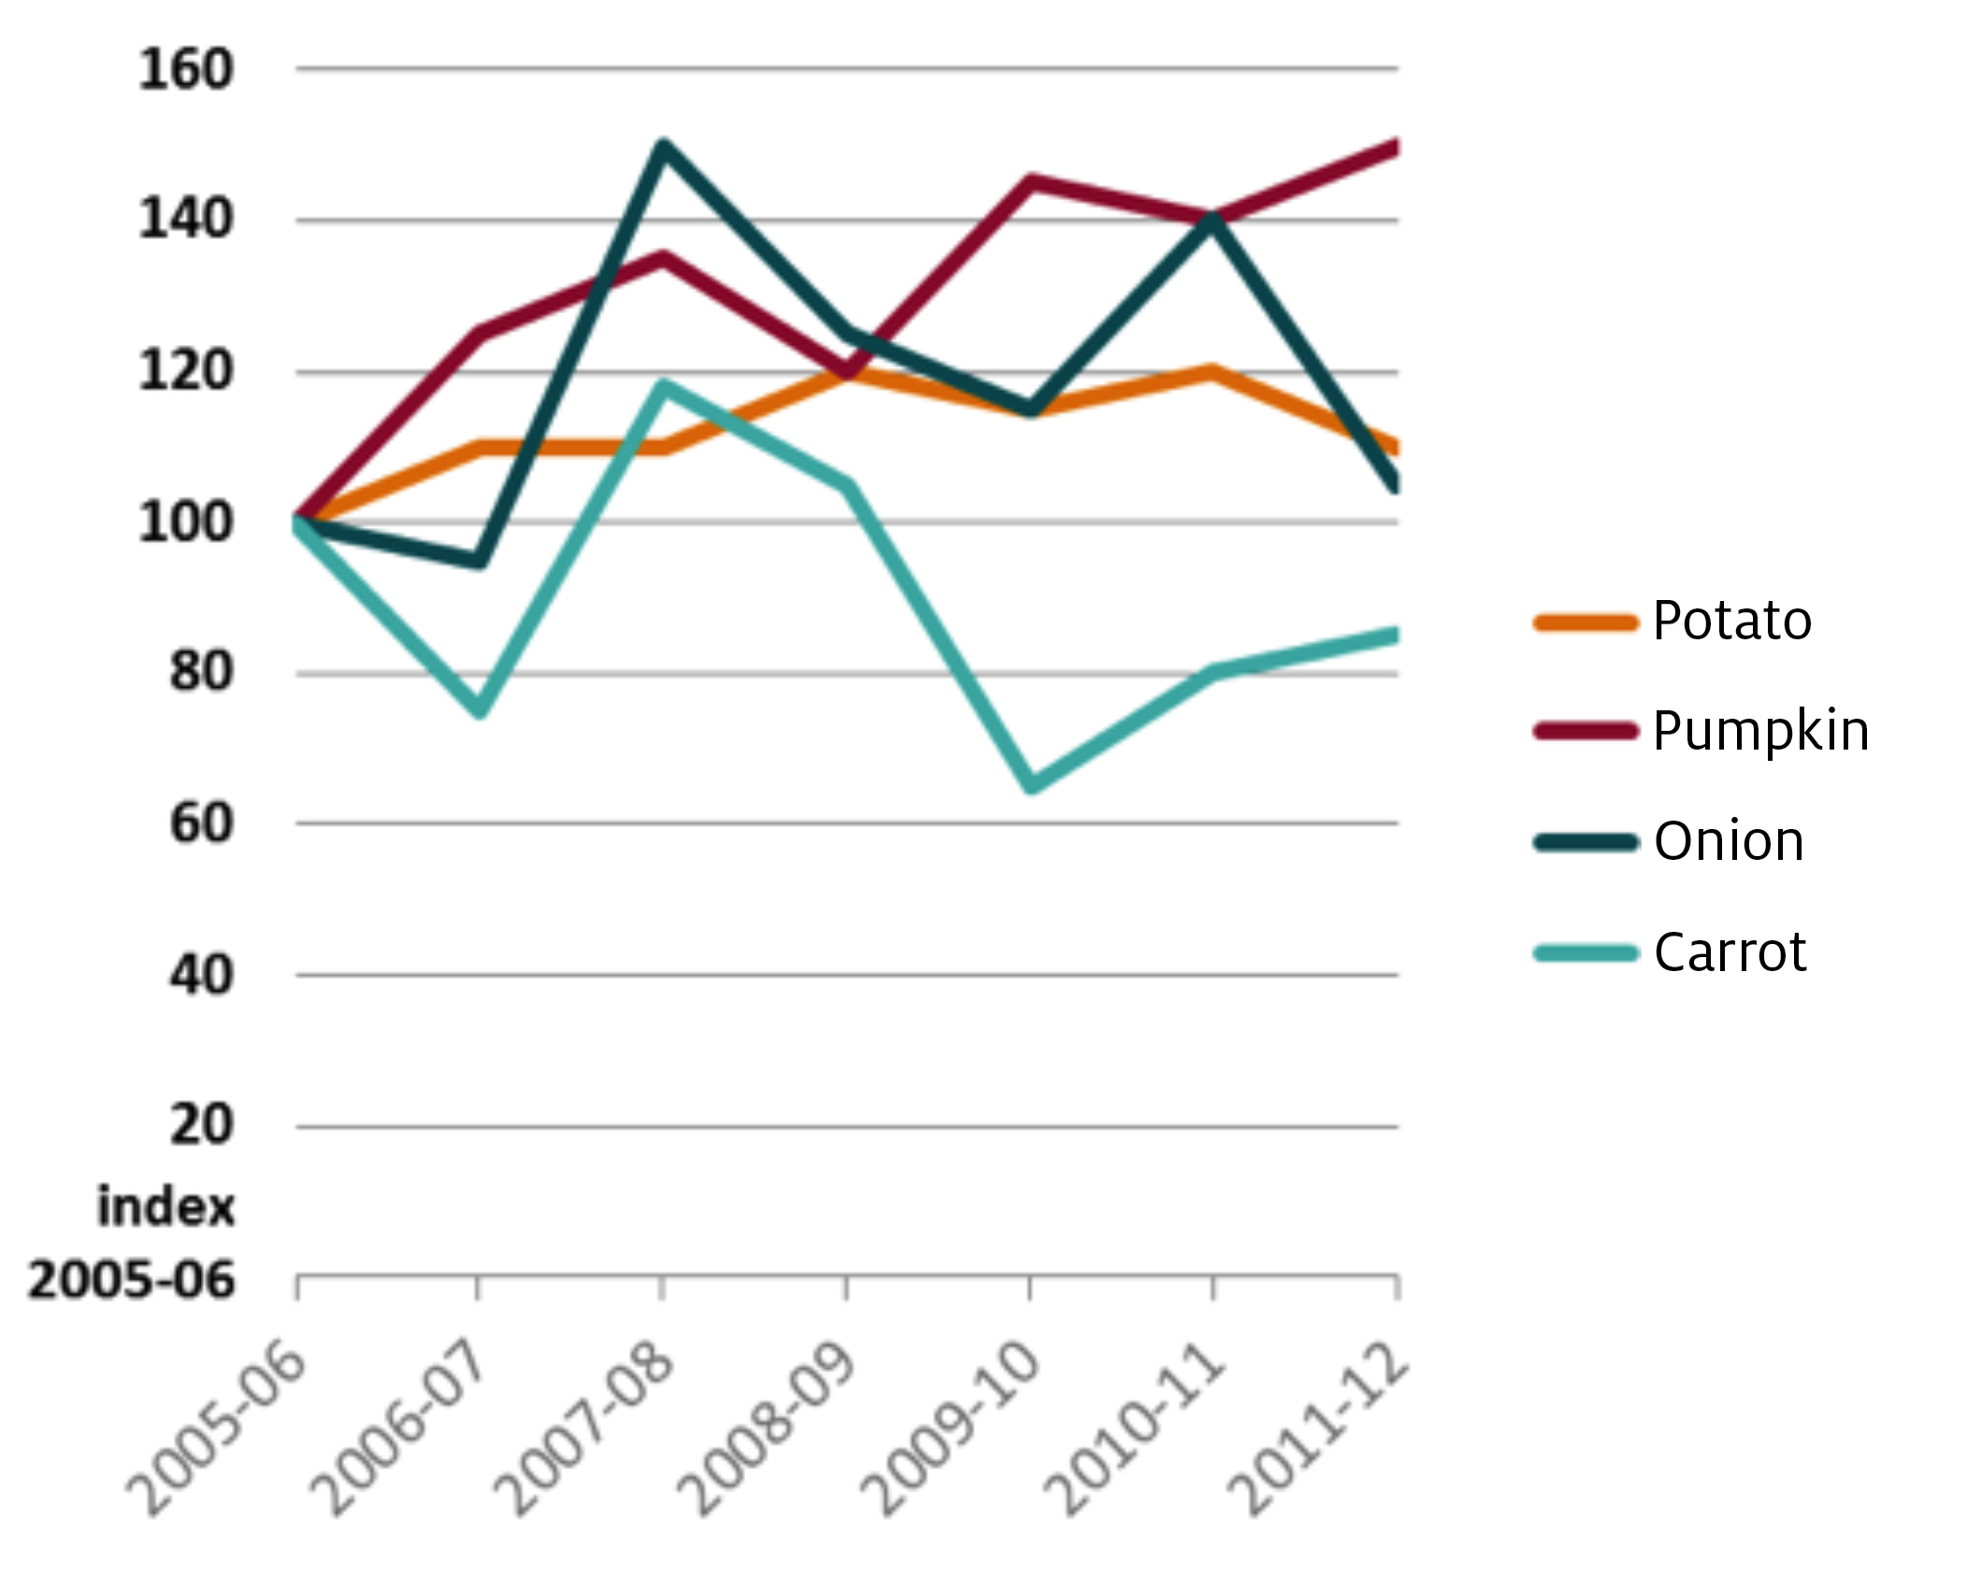

Source: ABARES

Box 1 Case study: Importance of flexibility in programmes

|  |
| --- |
| Having clear programme objectives can encourage participation by those farmers who feel their management objectives for farm or native vegetation can align with programme objectives. However, the programme objectives need to be supported by flexible working rules that reflect local circumstances and regional and sectoral contexts. |

Source: Australian Bureau of Statistics

#### Heading 4

Having clear programme objectives can encourage participation by those farmers who feel their management objectives for farm or native vegetation can align with programme objectives. However, the programme objectives need to be supported by flexible working rules that reflect local circumstances and regional and sectoral contexts (Stoneham et al. 2002).

Overall, the average price received for vegetables in 2010–11 increased by 23 per cent, mainly reflecting reduced supply due to production losses as a result of heavy rain and flood damage. Growers received higher average prices for most vegetables, but slightly lower prices for pumpkins and lettuce (Table 1).

Table 1 Total plantation area, by jurisdiction, 2011–12

|  |  |  |  |  |  |
| --- | --- | --- | --- | --- | --- |
| Jurisdiction | Unit | Joint p | Private | Public | Total |
| New South Wales | ’000 ha | 6 | 141 | 246 | 392 |
| Victoria | ’000 ha | 0 | 428 | 5 | 434 |
| Queensland | ’000 ha | 0 | 233 | 0 | 233 |
| South Australia | ’000 ha | 0 | 98 | 91 | 188 |
| Western Australia | ’000 ha | 44 | 290 | 71 | 405 |
| Tasmania | ’000 ha | 23 | 253 | 35 | 311 |
| Northern Territory | ’000 ha | 0 | 42 | 0 | 42 |
| Australian Capital Territory | ’000 ha | 0 | 0 | 8 | 8 |
| Total | ’000 ha | 73 | 1485 | 455 | 2013 |
| Proportion of tree ownership | % | 4 | 74 | 23 | 100 |

Note: p Preliminary estimate.

Source: ABARES Australian vegetable growing farms survey

The proportion of farmers who had applied for funding varied nationally (Map 1). The regions with the highest proportion of applicants were the Riverina area of New South Wales, most of Victoria, west and south-west Queensland and the Pilbara and central pastoral region in Western Australia (Crosthwaite & Macleod 2000; Tisdell 1985; Walpole 1999). The Darling Downs and Central Highlands region of Queensland and the Barkly Tablelands and Alice Springs District of the Northern Territory had the lowest proportion. Differences in regions may represent different regional contexts (including ecosystem or vegetative types) and differences in programme availability (Table 2).

Map 1 National Plantation Inventory regions

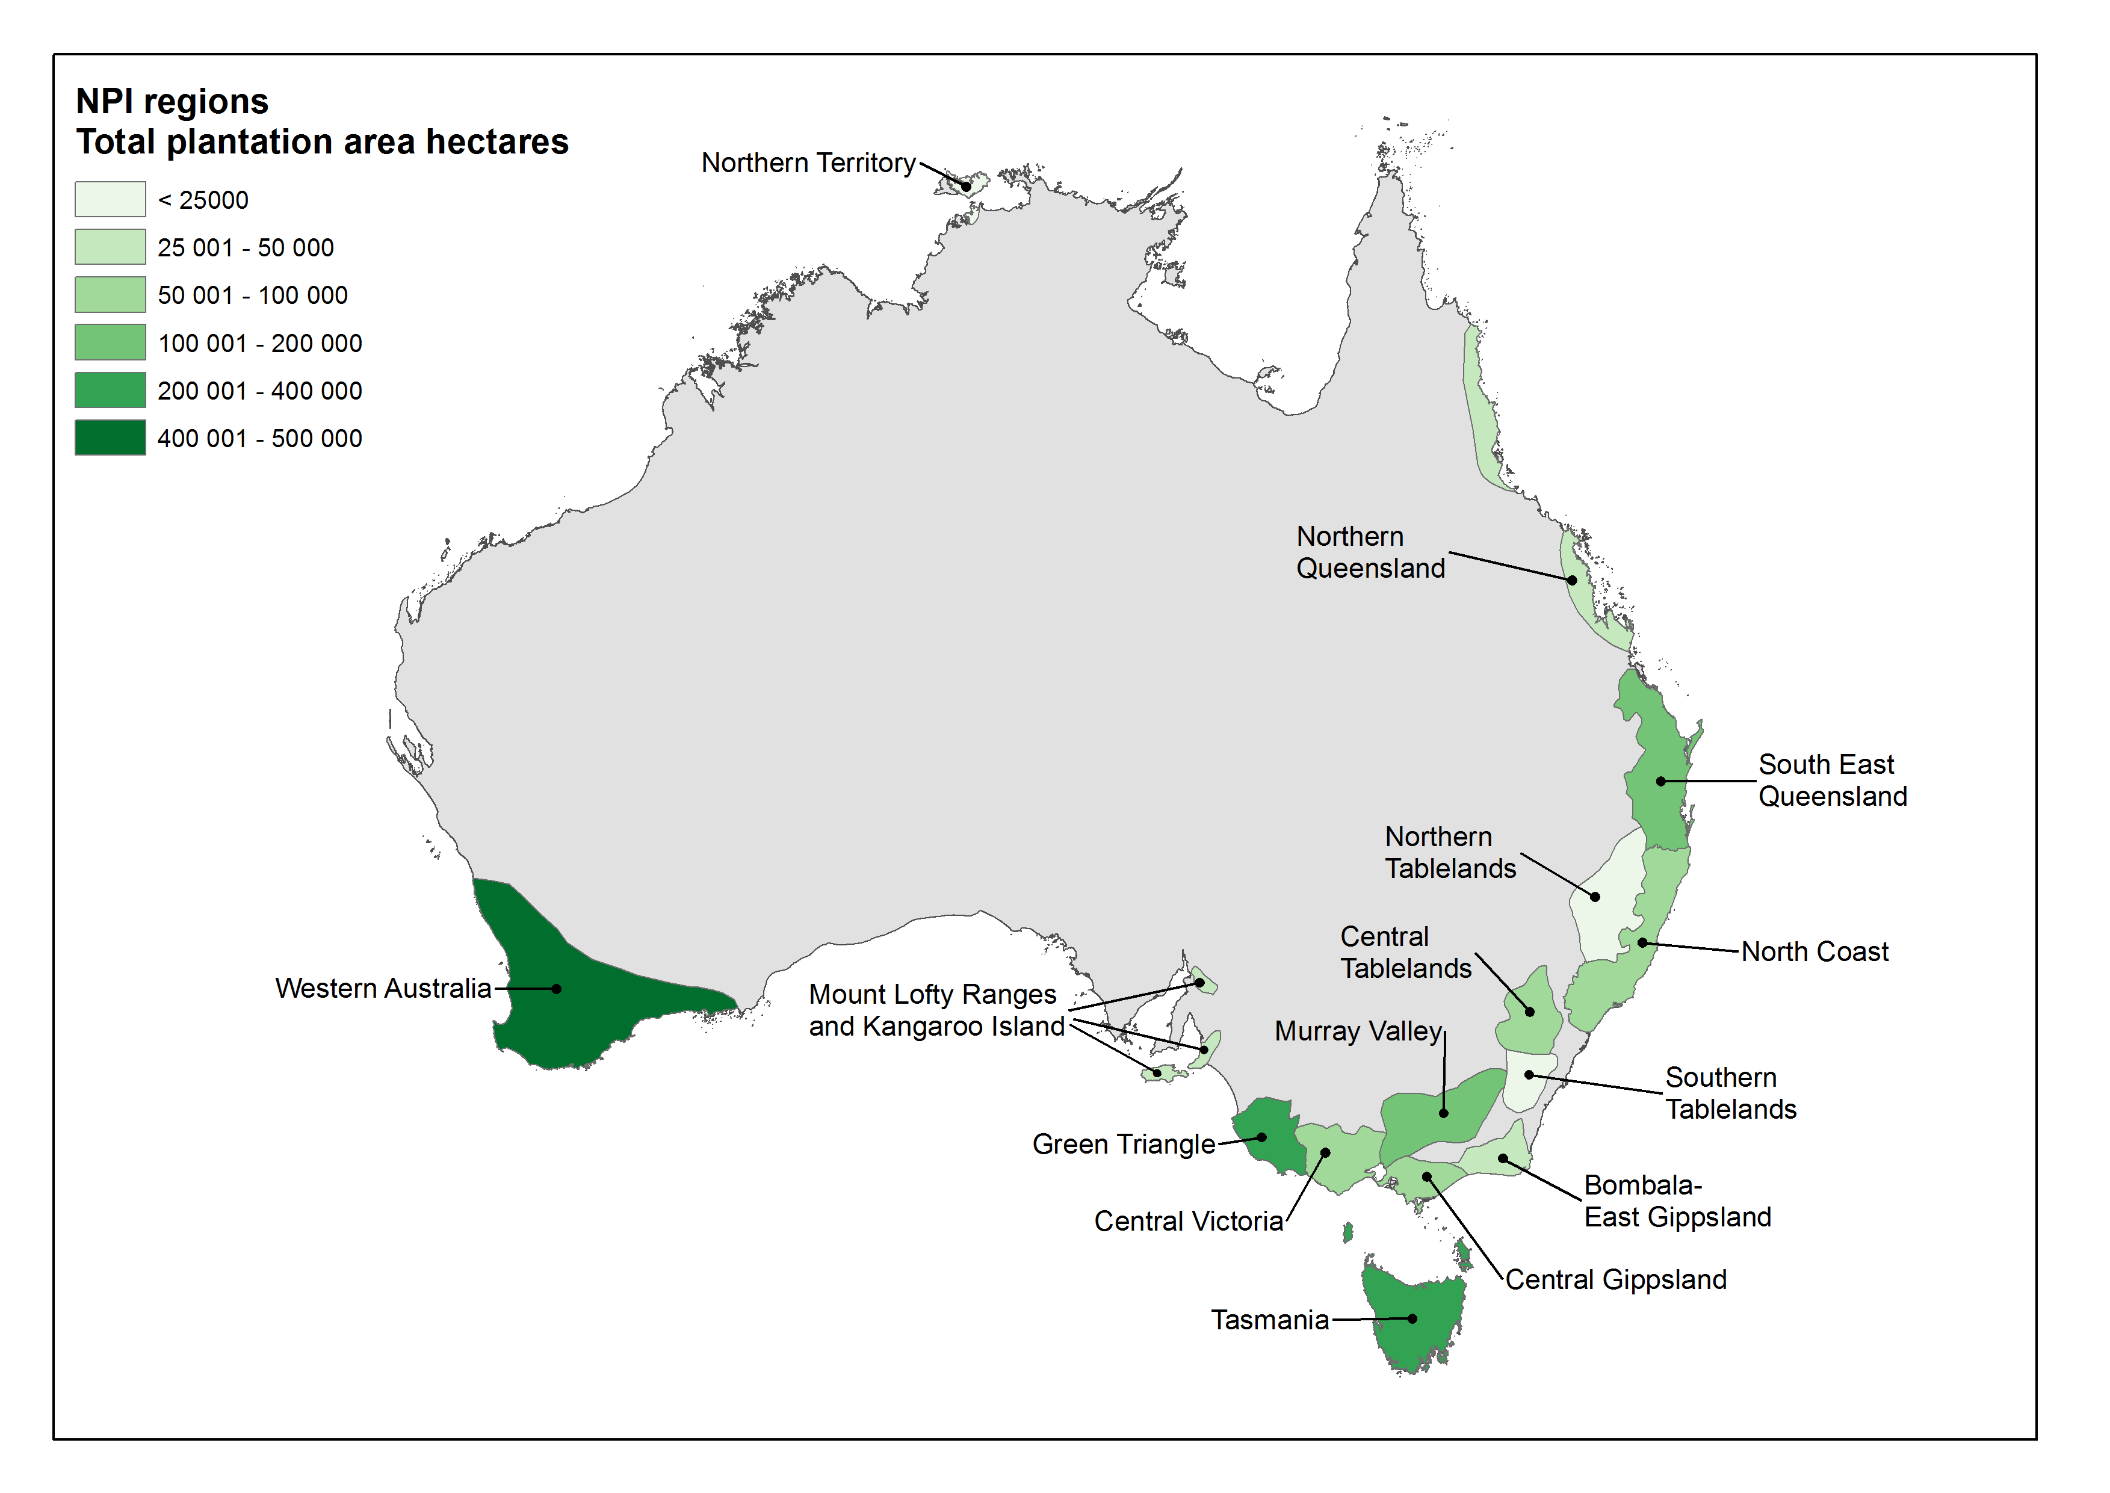

Source: ABARES

Table 2 Assumptions used in business-as-usual scenario

|  |  |  |  |  |  |
| --- | --- | --- | --- | --- | --- |
| Category (unit) | 2009–10 | 2019–20 | 2029–30 | 2039–40 | 2049–50 |
| Domestic resources | | | | | |
| * Broadleaved plantation area (’000 ha) | 980 | 980 | 980 | 980 | 980 |
| * Coniferous plantation area (’000 ha) | 1 025 | 1 025 | 1 025 | 1 025 | 1 025 |
| Domestic markets | | | | | |
| * Real GDP (2010A$b) | 1 284 | 1 719 | 2 211 | 2 832 | 3 555 |
| * Interest rate (%) | 6.0 | 6.8 | 6.8 | 6.8 | 6.8 |
| * Population (million) | 22.3 | 25.5 | 29.0 | 32.4 | 35.7 |
| * Real GDP per capita (2010A$/person) | 57 756 | 67 518 | 76 177 | 87 375 | 99 477 |
| * Manufacturing output (2010A$b) | 107.7 | 111.9 | 117.5 | 137.4 | 182.1 |
| * Household size (People/household) | 2.45 | 2.33 | 2.24 | 2.19 | 2.18 |
| * Total dwelling commencements (’000) | 165.5 | 188.3 | 222.7 | 254.2 | 281.8 |
| * Detached dwellings (’000) | 112.1 | 115.8 | 128.0 | 136.0 | 139.7 |
| * Multi-dwellings (’000) | 53.4 | 72.5 | 94.6 | 118.1 | 142.2 |
| * Share of multi-dwellings (%) | 32 | 38 | 42 | 46 | 50 |
| * Value of renovations a (2010A$b) | 6.5 | 9.6 | 13.5 | 17.8 | 22.4 |
| World markets | | | | | |
| * Exchange rate (A$–US$) | 0.88 | 0.97 | 0.97 | 0.97 | 0.97 |

Note: Value of renovations is reported here in 2010 Australian dollars using the ABS housing CPI re-based to 2009–10 dollars to allow for comparison with other market variables.

Source: Australian Government 2010–11; ABARES datasets

1. Production estimates

Table A1 New plantation areas, 2000, 2005, 2011 and 2012

| State or territory | 2000  (’000 ha) | 2005  (’000 ha) | 2011  (’000 ha) | 2012  (’000 ha) | 2000 to 2012  (%) | 2005 to 2012  (%) | 2011 to 2012  (%) |
| --- | --- | --- | --- | --- | --- | --- | --- |
| New South Wales | 2.2 | 7.4 | 0.3 | 0.4 | –84 | –95 | 14 |
| Victoria | 37.7 | 10.9 | 3.1 | 1.0 | –97 | –90 | –66 |
| Queensland | 3.9 | 9.7 | 1.9 | 0.8 | –79 | –92 | –58 |
| South Australia | 15.1 | 6.0 | 0.1 | 0.0 | –100 | –100 | –100 |
| Western Australia | 64.8 | 22.4 | 0.4 | 0.4 | –99 | –98 | –20 |
| Tasmania | 12.6 | 10.0 | 1.5 | 0.1 | –100 | –99 | –96 |
| Northern Territory | 1.2 | 5.7 | 2.2 | 1.6 | 31 | –72 | –28 |
| Australian Capital Territory | 0.0 | 0.0 | 0.0 | 0.0 | na | na | na |
| Total | 137.5 | 72.0 | 9.6 | 4.2 | –97 | –94 | –56 |

Note: New plantations are those established on land not previously used for plantation forestry. 2000 and 2005 are calendar years and 2011 and 2012 are financial years (2010–11 and 2011–12). All columns and rows have been rounded so column and row totals may not tally.

Source: ABARES

Table A2 Notes on southern bluefin tuna recreational fishing activities and monitoring programmes based on presentations and discussions at the 2011 technical workshop

|  |  |  |  |  |
| --- | --- | --- | --- | --- |
| Attribute | New South Wales | Victoria | South Australia | Western Australia |
| Gaps | Game fishing club members outside tournaments and non-club anglers are difficult to monitor. | No southern bluefin tuna catch monitor programmes are planned after 2011. | 1. Reporting released numbers in log books 2. Lack of validation of logbook data 3. Size composition of catches, no regular programme of monitoring 4. Estimates from general recreational fishery for southern bluefin tuna very patchy 5. Proposed new general recreational fishery survey in 2012 | No time series data available for recreational catches of southern bluefin tuna. The charter boat logbook has been compulsory since June 2001. |

Source: ABARES

Glossary

BLUP best linear unbiased prediction

FAO Food and Agriculture Organization of the United Nations

R&D research and development

References

Unless otherwise indicated, ABARES publications listed here are available at [agriculture.gov.au/abares/publications](http://agriculture.gov.au/abares/publications).

ABARES 2012a, Australian beef—financial performance of beef cattle producing farms, 2009–10 to 2011–12, Australian Bureau of Agricultural and Resource Economics, Canberra, available at [adl.brs.gov.au/data/warehouse/9aabf004/abfpf/abfpfd9aabf00420120629/AustBeef_2012_v1.0.0.pdf](http://adl.brs.gov.au/data/warehouse/9aabf004/abfpf/abfpfd9aabf00420120629/AustBeef_2012_v1.0.0.pdf) (pdf 2.33mb).

ABARES 2012b, Agricultural commodities: September quarter 2012, Australian Bureau of Agricultural and Resource Economics and Sciences, Canberra, available at [adl.brs.gov.au/data/warehouse/agcomd9abcc004/agcomd9abcc004201209/AgCommodities2012.Vol2.No3_Ver1.1.0.pdf](http://adl.brs.gov.au/data/warehouse/agcomd9abcc004/agcomd9abcc004201209/AgCommodities2012.Vol2.No3_Ver1.1.0.pdf) (pdf 5.51mb).

ALA 2013, Explore [home page], Atlas of Living Australia, Canberra, available at [ala.org.au](http://www.ala.org.au/).

Brickley, C 2002, ‘Extending eco-label standards to include soil and water quality: the Protected Harvest approach’, conference on Ecolabels and the Greening of the Food Market, Boston, MA.

Crosthwaite, J & Macleod, ND 2000, ‘Retaining native vegetation on farm: Understanding its private value’, in Craig, JL, Mitchell, N & Saunders, DA (eds), *Conservation in production environments: Managing the matrix*, Surrey Beatty and Sons, Chipping Norton, New South Wales, proceedings of Conservation Networks Conference 5, Taupo, New Zealand, 1997.

Light, D 2000, ‘A tax of the jitters’, *Bulletin*, 18 January, pp. 50–1.

Rutherford, TF 1995, ‘Extension of GAMS for complementarity problems arising in applied economic analysis’, Journal of Economic Dynamics and Control, vol. 19, no. 8, pp. 1299–1324.

Stoneham, G, Chaudri, V, Ha, A & Strapazzon, L 2002, ‘Auctions for conservation contracts: an empirical investigation of Victoria’s bush tender trial’, 46th Australian Agricultural and Resource Economics Society Conference, 13–15 February, Canberra.